

Department of Electronic & Telecommunication Engineering

University of Moratuwa

EN3250 Internet of Things

Individual Assignment

2020 Batch - Semester 5

26/10/2023

**200650U Thilakarathne D.L.J**

Problem 1

1. AP keeps transmitting beacons, and the Nokia mobile device(STA) uses Active scanning. STA instantiates probe requests. The AP responds to those probe requests with probe request responses. There are other devices as well, but we’re focusing on these.
2. STA send multiple probe requests and AP send multiple probe request responses as well.  
     
   A screenshot of a computer

   Description automatically generated  
     
   But at one point STA enters the Authentication phase. The interchange of information between the AP and the STA, where each side proves the knowledge of a given password.  
     
   A screenshot of a computer

   Description automatically generated  
     
   Then the device sends an association request frame to the AP.  
     
   A screenshot of a computer

   Description automatically generated  
     
   The AP subsequently reply with an association response frame that will allow the STA to join the network or be excluded. Then the STA is included, the AP releases an association ID to the client and add it to the list of connected clients. At this point, data can be exchanged with the AP and vice versa. All data frames will be followed by an acknowledgment.
3. SSID: Siemens_41:bd:6e  
   BSSID: 00:01:e3:41:bd:6e  
     
   The pair (BSSID, SSID) found by any device at a particular location is called the “fingerprint” of that location.  
   This is unique to a given physical location, and hence a useful feature for localization.  
   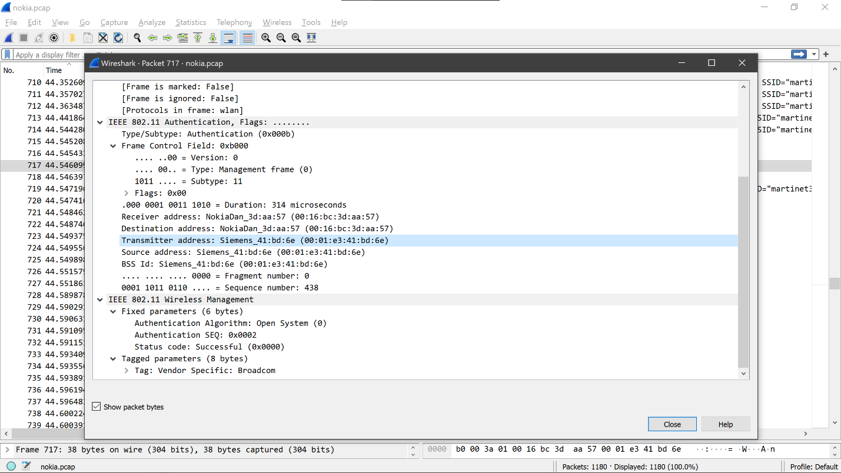
4. Passive scanning:
   1. uses beacons and probe requests.
   2. After a channel is selected, the device performing the scan will receive beacons and probe requests from nearby STAs.
   3. An access point may transmit a beacon, and if the STA receives the transmission, it may progress to join the network.
   4. This mode of scanning uses less power.
   5. By opening a captured beacon sent:  
        
      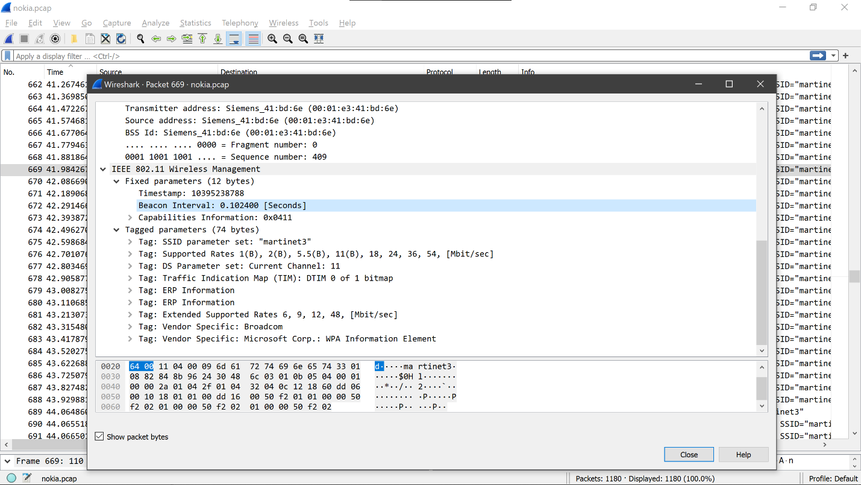
   6. By checking the time interval between the beacon transmissions.  
        
      A screenshot of a computer

      Description automatically generated  
        
      Calculation  
      41.881864 - 41.779463 = 0.10240100000000 s
5. A screenshot of a computer

   Description automatically generated

Problem 2

1. For example,  
   Skip Time Resource:   
   This resource could be identified as /.well-known/skip-time. The skipping rope could expose the time duration of the skip in milliseconds through this resource. The endpoint could be something like,  
   coap://<skipping_rope_IP>/.well-known/skip-time.  
     
   Total Skip Number Resource:   
   This resource could be identified as /.well-known/total-skip-number. For instance, the skipping rope could expose the total count of skips through this resource. The endpoint could be something like,  
   coap://<skipping_rope_IP>/.well-known/total-skip-number.

Calories Burned Resource:  
This resource could be identified as /.well-known/calories-burned. It could provide the number of calories burned during the skipping session. The endpoint could be something like,  
coap://<skipping_rope_IP>/.well-known/calories-burned.  
  
Tangles Resource:  
This resource could be identified as /.well-known/tangles. It could indicate the number of times the rope has tangled during the session. The endpoint could be something like,  
coap://<skipping_rope_IP>/.well-known/tangles.  
  
Battery Level Resource:   
This resource could be identified as /.well-known/battery-level. It could reveal the current battery level of the skipping rope. The endpoint could be something like,  
coap://<skipping_rope_IP>/.well-known/battery-level.

1. A diagram of a software server

   Description automatically generated
2. Advantages of using CoAP:
   * Lightweight Protocol
   * RESTful Interaction
   * Efficiency in Small Data Transfers
   * Less Complex Implementation

Disadvantages of using CoAP:

* Limited QoS Support
* Scalability Issues
* Limited Broker Functionality.
* Security Concerns

Problem 3

* + Machine usage
  + Power usage
  + Worker presence
  + Machine Idle times/ efficiency
  + Inventory updates/ Water tanks

1. Consider the Machine usage and Power usage
   * Monitoring the power usage allows to avoid any failures, plant shutdown etc.
   * Machine usage monitoring will allow to optimize the production line, reducing unwanted power consumption, produce more output etc.
2. The main challenge it that the production line must not stop while digitalization. The experts at TeeJay Lanka PLC showed that, they implemented the IOT devices parallel to the production line
3. _
4. The main factors would be the ROI.